## Current State Map: HELL’s Software Tool Management System

## From Customer gets authorization signature to customer is notified upon completion of request

## 

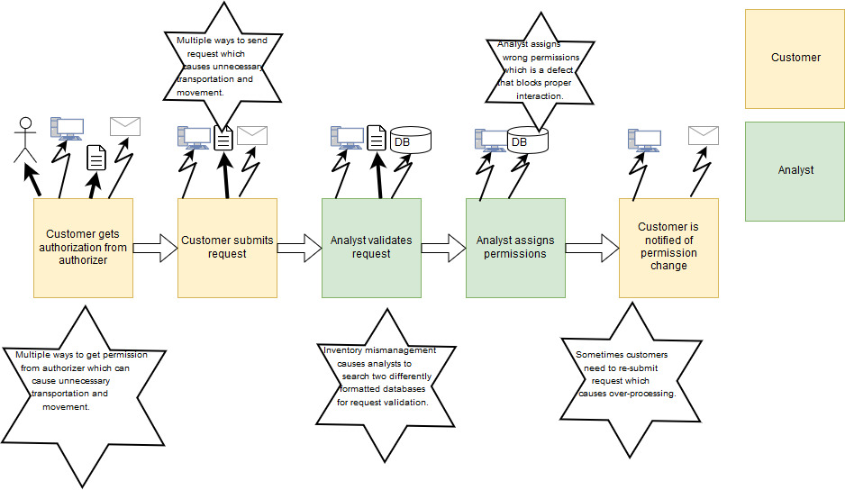

Team Members:

Maksym Z.

Earl M.

Jennifer H.